1. **Create Storage Account Create a Blob service/ File Share/ Table/Queue in Storage account**

**Ans:**

* **Step 1: Create a Storage Account**

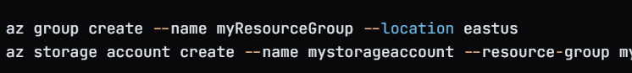

* **Step 3:Create a Blob Service**



* **Create a File Share**



* **Step 5: Create a Table:**



* **Create a queue**



* **USING AZURE SDKS**

